**TASK -10**

**Q1. Output Screenshot:**

**\***Navigate to the URL – https://jqueryui.com/datepicker/

**\***Print the Selected date in the Console

**Q2.Output Screenshot:**

**\***Navigate to the URL - https://jqueryui.com/droppable/

**\***Print the Output in the Console

**Q3.Ouput Screenshots:**

**\***Navigate to <https://www.guvi.in>

*Screenshots of Execution

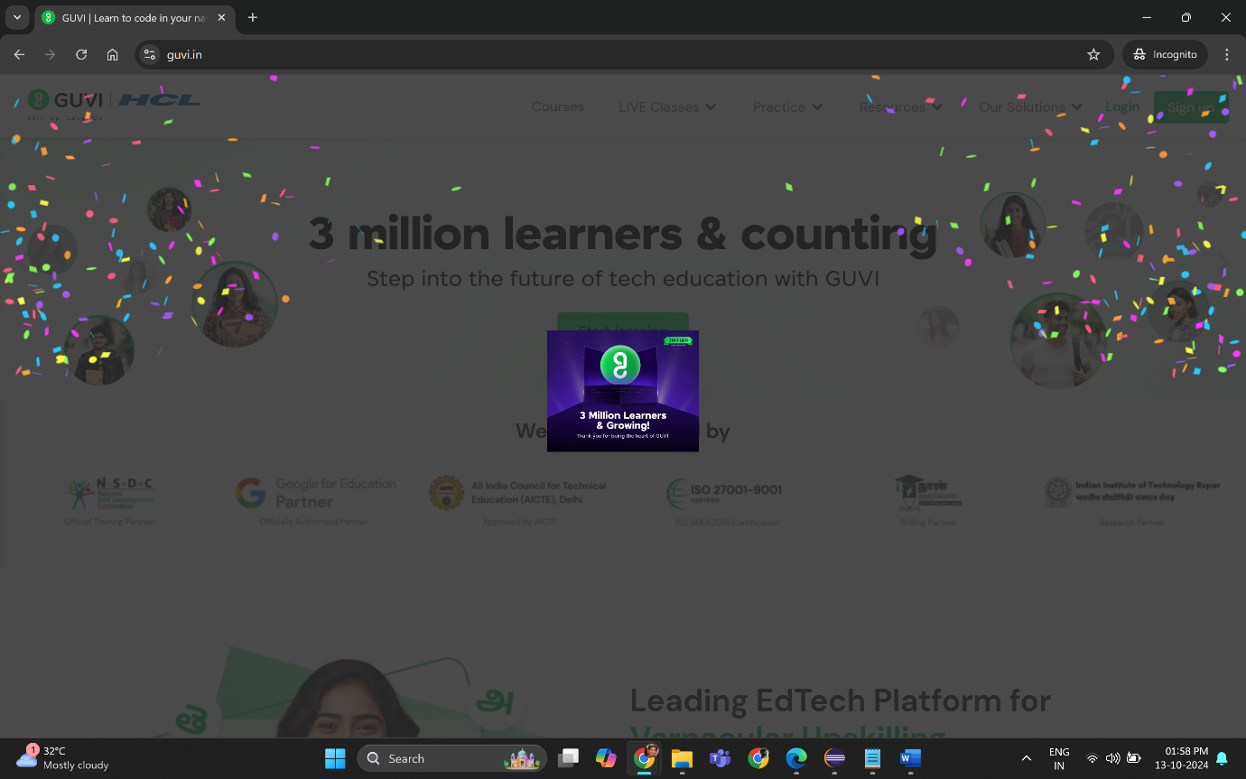

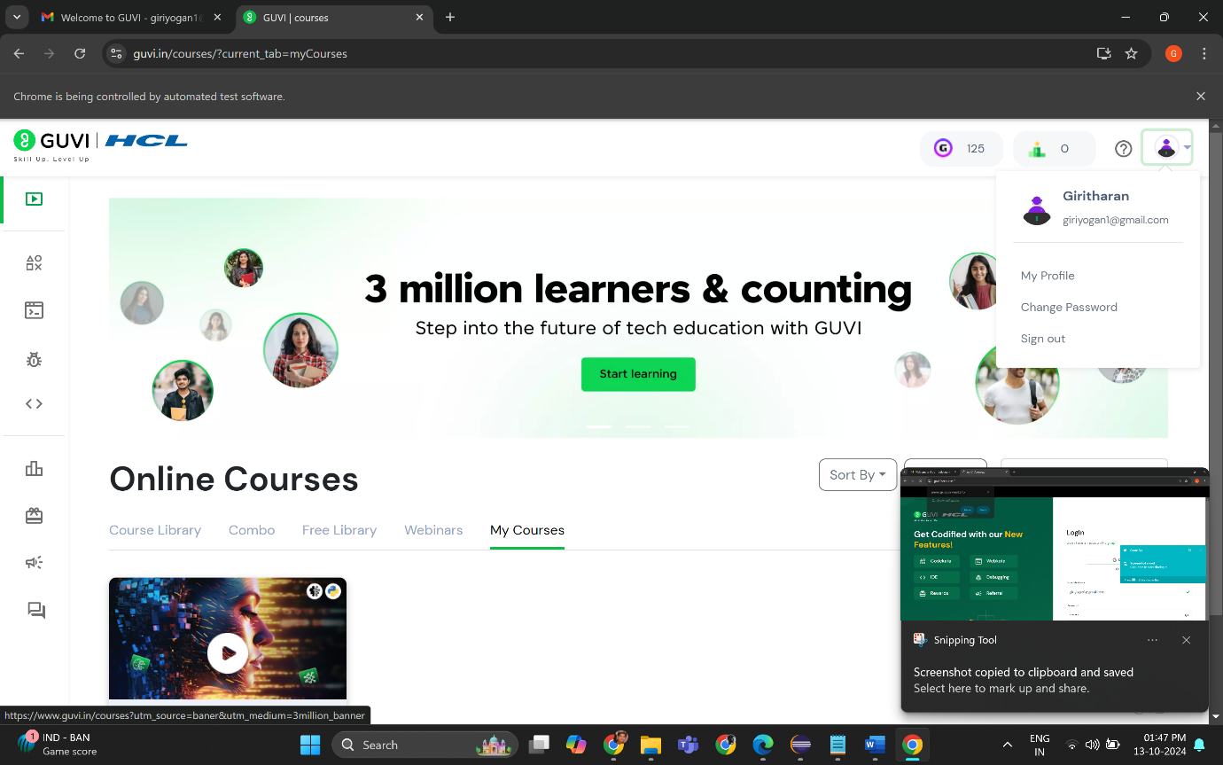

*Screenshot of Console

